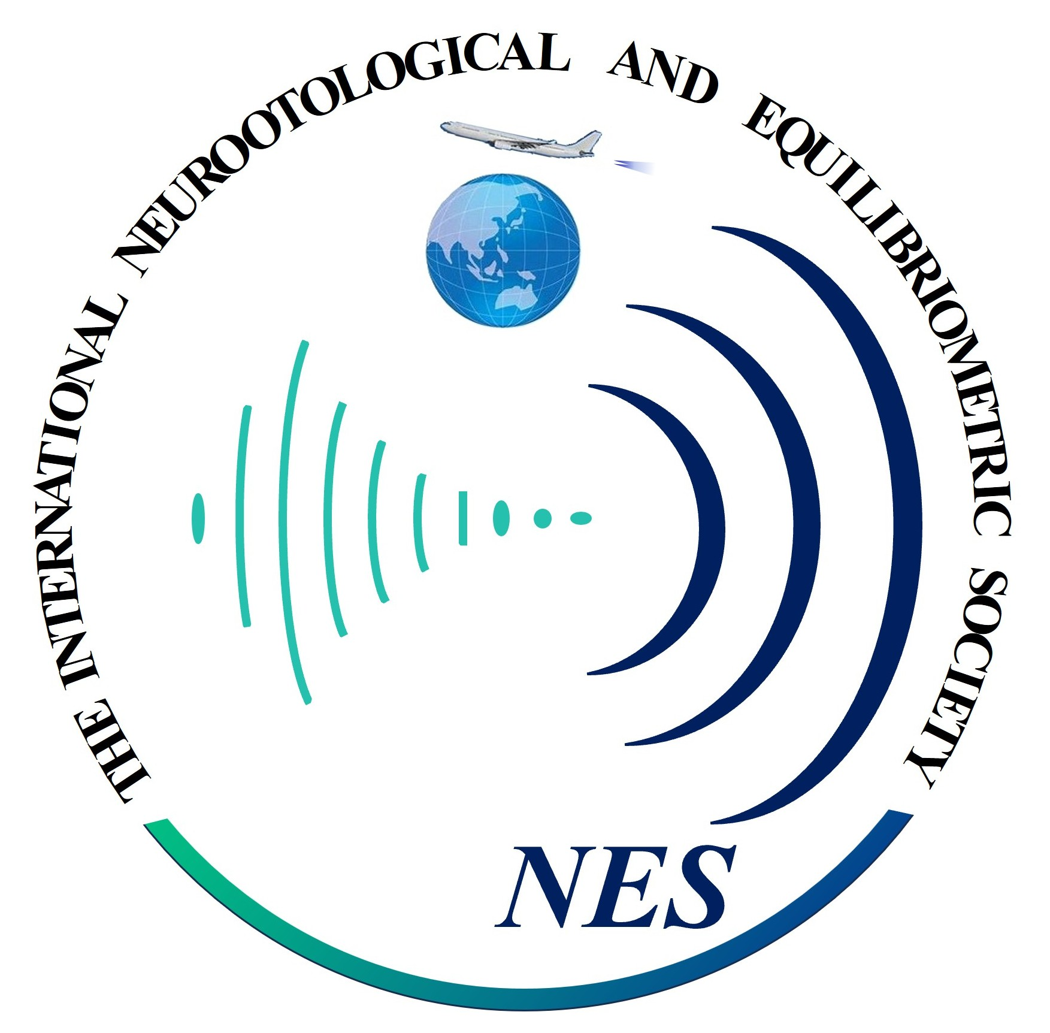
NEUROOTOLOGICAL AND EQUILIBRIOMETRIC SOCIETY (NES)
Application for Membership of the NES
Please send this application via E-mail ( nes2025@jikagaku.jp ).

To the
Neurootological and Equilibriometric Society (NES)
Kawagoe Ear Institute
Kawagoe-Mine Medical Center 2F, 103 Wakitamachi, Kawagoe-shi, Saitama 350-1122, Japan
Tel: +81-49-226-3387
E-mail: nes2025@jikagaku.jp

Herewith I apply for membership in the Neurootological and Equilibriometric Society (NES).

Prefix: [ ] Prof. [ ] Dr. [ ] Other: ____________________________________
First name: ________________________________________
Middle name: ______________________________________ (If not applicable, please write (None) or N/A)
Last name: ________________________________________
Institution: ________________________________________
Address:
Telephone: ____________ ________ E-mail: _________ ___________

In case of being accepted, I agree to pay the annual membership fee of JPY 15,000 by bank transfer to the bank account of the NES as follows:
Bank Name: Saitama Resona Bank, Ltd.
Branch Name: Kawagoe Branch
Branch Address: U_PLACE 4F, 8-1 Wakitahoncho, Kawagoe-shi, Saitama 350-1123, Japan
SWIFT Code (BIC): SAIBJPJT
Bank Address (Head Office): 7-4-1 Tokiwa, Urawa-ku, Saitama-shi, Saitama 330-9088, Japan
Account Number: 4673487
Account Type: Ordinary Account

Account Name (Beneficiary): KOKUSAIHEIKOUSINKEIKAGAKUKAI (NES)
Account Holder's Address: Kawagoe-Mine Medical Center 2F, 103 Wakitamachi, Kawagoe-shi, Saitama 350-1122, Japan

I understand that I can end this membership by written cancellation.

Date:_____________________________ Signature: _____________________________________________
Note: The official account name registered with the bank is “KOKUSAIHEIKOUSINKEIKAGAKUKAI”.
For international remittance, writing “NES” alone is also acceptable and will be recognized as the same beneficiary.

